CSE-ASSIGNMENT 4

-V.PHALGUN

AP21110010223

CSE-D

1.List of Managers Code:

#include<iostream>

using namespace std;

class manager

{

    int Eid;

    char Name[30];

    int age;

    public:

    void getdata();

    void putdata();

};

void  manager::getdata()

{

    cout<<"Enter Employee Id: ";

    cin>>Eid;

    cout<<"Enter Employee Name: ";

    cin>>Name;

    cout<<"Enter Employee Age: ";

    cin>>age;

}

void manager::putdata()

{

    cout<<Eid<<" ";

    cout<<Name<<" ";

    cout<<age<<" ";

    cout<<endl;

}

int main()

{

    manager emp[30];

    int n,i;

    cout<<"Enter number of manager";

    cin>>n;

    for(i=0;i<n;i++)

    {

        emp[i].getdata();

    }

        cout<<"Manager data " <<endl;

        for(i=0;i<n;i++)

        {

        emp[i].putdata();

        }

        return 1;

}

Output:

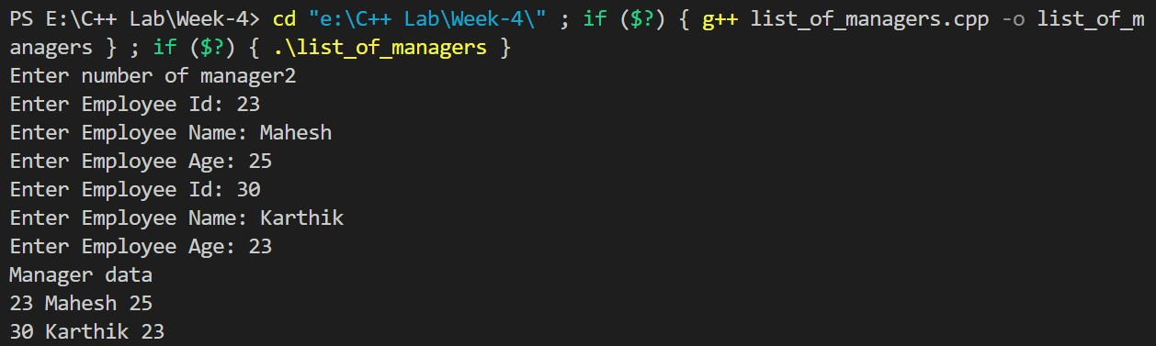

2.Friend Function Code:

#include<iostream>

using namespace std;

class ABC;

class XYZ

{

    double x;

    public:

    void set_data(double a)

    {

        x=a;

    }

    friend void max(XYZ,ABC);

};

class ABC{

    double y;

    public:

    void set_data(double a)

    {

        y=a;

    }

    friend void max(XYZ,ABC);

};

void max(XYZ t1,ABC t2)

{

    if(t1.x>t2.y)

    cout<<t1.x;

    else

    cout<<t2.y;

}

int main()

{

    ABC _abc;

    XYZ _xyz;

    _xyz.set_data(534);

    _abc.set_data(289);

    max(_xyz,_abc);

    return 0;

}

Output:

